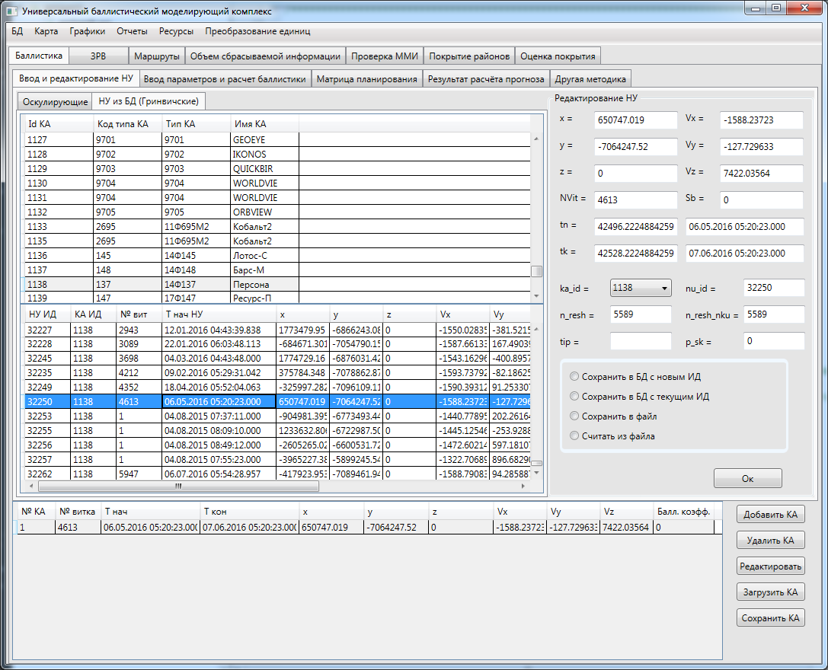

|  |  |  |  |  |  |  |  |  |  |  |
| --- | --- | --- | --- | --- | --- | --- | --- | --- | --- | --- |
| 1 | 4613 | 06.05.2016 05:20:23.000 | 07.06.2016 05:20:23.000 | 650747.019 | -7064247.52 | 0 | -1588.23723 | -127.729633 | 7422.03564 | 0 |

Ka_id 1138 **nu_id 32250** n_resh 5589 n_resh_nku 5589